AGROECOLOGY FUND SMALL GRANT
FINAL REPORT –By H.W.SINGILI
Contract #: NVF-AAES-East and Southern Small-Subgrant-011495-2020-06-01
Organization: East and Southern Africa Small Scale Farmers’ Forum (ESAFF) Zambia
Country: Zambia
Implementation starting date: June 1, 2020
Completion date: December 31, 2020
Amount Granted: USD 15,000
Date of report submission: 5th February 2020
Contact person: Henry Singili
E-mail: hwsingili@yahoo.co.uk
SECTION 1 – ACTIVITIES REPORT
- PARTICIPATING ORGANIZATIONS: Please list the organizations that participated in the implementation of this initiative and their respective roles. Acronyms should be accompanied by the full name of the organization.
The initiative was implemented by ESAFF Zambia Small Scale farmer group members in Sefula Community of Mongu District in Western Province of Zambia. The farmers groups that participated included:
- Nakasheke Farmers’ group
- Sibata Farmers’ Group
- Nalikolo Farmers Group
- Kazulu Farmers’ Group
- TERRITORY: Please provide a brief description of the territory whether this initiative has been implemented, indicating the sites names (communities, cities, departments, etc.).
The project was implemented in the Sefula community in the district of Mongu. Sefula is a rural farming settlement on the Barotse plain comprising of four villages, Nakasheke, Sibata, Nalikolo and Kazulu in which the project sites are located. Sefula lies 20 kilometers east of the Mongu town, the district headquarters. Majority of the population of the Sefula community are small scale farmers who mainly grow rice, maize, cassava and a variety of vegetables which include rape, Chinese cabbage, cabbage, tomatoes, onions and okra among other leafy traditional vegetables for their consumption and sale. The community has a referral hospital and a secondary school which is run by the Seventh Day Adventist Church .There is also a small shopping center which is linked by a gravel road to the main highway to Mongu town-the administrative center.
- BENEFICIARIES: What are the social groups that have been benefited with this intervention in each of the implementation sites (please include numbers whenever possible, specifying % of women, youth, indigenous peoples, fishermen, etc., where appropriate.)
The beneficiaries of the project are resource poor small scale farmers (women, men and the youth).The project covered 2000 households (Nalikolo 500 HH, Nakasheke 600 HH, Sibata 500HH and 400HH) with a total of beneficiaries 10,000 ( 6500 women,2700 men and 800 youths).In addition, other members of the community associated with the agricultural sector eg.landless agricultural labourers, fishermen, local traders and input suppliers also benefitted through reduced vulnerabilities and sustained incomes of the primary beneficiaries.
- CONTEXT: What have been the main impacts of the pandemic on the agri-food systems in the territory where this intervention took place?
Covid 19 hit the Sefula community at a particularly critical time- when farmers were ready to harvest their farm produce especially maize and fresh vegetables and fruits. In an effort to control the spread of the pandemic imposed lockdown, travel restrictions and social distancing measures. The impact of these measures has been in a number of ways:
- Disruption of the Government initiated Farmer Input Support Programme (FISP) where most of the small scale farmers source their farm inputs and the support services like , extension and advisory services. With the clampdown on people’s movement and disruption of transport, the supply of these inputs and services were suspended including those associated with the agro-dealers. This included the supply of seeds, fertilizers and pesticides.
- It affected the harvesting activities, labor availability and transportation of harvest to storage facilities.
- Transport restriction along supply routes coupled with the ‘stay-at-home’ advice meant that small scale farmers, processors and retailors had logistical challenges leading to supply delay and post-harvest losses. This has resulted in artificial food shortages and high prices.
- The closure of Sefula market among other urban markets in the outlying districts disrupted the food supply systems especially the supply of fresh vegetables, fruits and eggs. This impacted negatively on the incomes of Sefula households who rely heavily on the informal markets.
- Family remittances to Sefula from relatives who live and work in urban areas have drastically reduced as most of the urban workers in the formal sector were laid off. This resulted in limited purchasing power of Sefula families and reduced demand for healthy diets and the capacity to access farm inputs and implements for increased production.
- Local communities resulted to burning charcoal as an alternative source of income which is promoting deforestation forest and the ecosystem.
- School feeding program which has been providing food to pupils in schools have also closed down. This means loss of income for the local suppliers of foodstuff to the programme at local level and also added challenges to family limited food at home.
- ACTIVITIES: Please describe the activities that have been implemented (please give us numbers whenever is possible).
Activities implemented:
- Mobilization, identification and registration of the beneficiary households.
The activities were undertaken with the assistance of community leaders and the district administration so as to ensure fairness in the selection of the beneficiaries and especially those who are most in need. The exercise identified 2000 households (10,000 indirect beneficiaries) who would benefit directly or in directly from the project. The beneficiary households consisted of those with minimal household assets but were making ends meet through farming and livestock rearing activities and households with unemployed youths most of whom are school drop-outs who are not gainfully engaged. The households were sensitized about the project and the expected results. The beneficiaries included 6500 women, 2,700 men and 800 youths within the Sefula community..
- Community interface meetings
Two community interface meeting were held to familiarize the community with the ideals of the project and to plan for its implementation by community beneficiaries. The meetings brought together the various stakeholders which included small scale farmer group representatives, Government officials, community leaders, women and youth leaders, civic leaders and Faith-based organizations. 80 participants attended the two meetings that were composed of 43 women, 27 men and 10 youths.
- Trainings.
Based on the needs earlier identified during the design of the project the following trainings were conducted:
- Agroecological farming practices
The training was conducted for 50 small scale farmers lead farmers on Training of Trainers (TOT) basis. Each trained farmer was expected a further 20 farmers in the community and the process to continue until all the 2000 households were covered. The training sessions consisted of the principles of agroecology and the various farming techniques used including intercropping, production of green manure, agroforestry, crop diversification, ‘push pull’ systems, production of green manure among other agroecology techniques that allow for limited use of chemical fertilizer and pesticides.
- Fish farming
The training was conducted for 40 participants on a ToT basis in which 50% of the participants were youths. The two day sessions included aquaculture management, Pond design and Construction, Suitable fish species in Zambia and Fish pond Management. The training was conducted by a facilitator from the Ministry of Fisheries and Livestock with input from Ministry of Agriculture and ESAFF Secretariat.
- Livestock production
The training was conducted for 50 participants with a 60% participation being women. The training mostly centered on poultry, goat and pig rearing with emphasis on healthy living, nutrition and income generation. The training focused on bio-safety, disease control and general poultry and animal management including feed formulation and housing. The farmers were also educated on common poultry and animal disease management through drugs and vaccines use , and access to markets. The training was facilitated by officials from the ministry of Fisheries and Livestock, Ministry of Agriculture and input from the ESAFF Zambia Secretariat.
- Financial management training
The training was recommended by farmers after realizing that there was lack of adequate financial management skills among the farmers groups. The training was attended by 25 participants with 40% participation by youths. The training focused on providing small scale farmers with skills of financial management particularly the importance of keeping farm records, proper planning, and proper financial management. The discussions in this training helped the farmers to know the importance of not only planning and financial management, but involving a spouse in decision-making at family level and on how to run faming as a business.
- Provision of farm inputs and implements
The projects provided four village groups (400 most needy households) with farm inputs which included indigenous maize and vegetable seeds and including farm implements like shovels, hoes and machetes. Vegetable seeds included okra, tomatoes, sweet potato leaves, cassava leaves, pumpkins, eggplant and a variety of other indigenous leafy vegetables. The maize seed provided was for the early maturing and included the local varieties which normally take three months to mature. 300 households benefited from farm inputs and implements provision.

- income generation activities
Income generating initiatives included (a) fish farming -which was youth run and involved stocking four fishponds with 3000 fingerlings each. Each fish pond is expected to harvest 2700 fish (900 kg) at a price of K. 45 per kilo. This would amount to K.31, 500 at each harvest part of which would be ploughed back to the project to benefit 800 unemployed youths and their families (b) Village chicken rearing that involved the construction of four chicken housings with capacity to hold 200 chickens each. These are mainly run by both men and women from the four community groups. Eight hundred local chicken and feed for three months were purchased locally and supplied to the groups. It is expected that by the end of three months each group will have at least 1200 birds ready for sale at a cost of K. 65 making a total of K. 78,000. In total, all the groups would put on sale in the first three months a total of 4,800 chicken on sale at a price of K.65 which would give them a total of K 312,000 ( c) Rearing of goats and pigs: households had a choice of whether to accept to rear goats or pigs. Majority accepted to keep goats and 200 households were supplied with two goats each while 100 were supplied with two pigs each (male & female).It was expected that the small ruminants would help the households meet their dietary needs and generate some income for their households while helping them to prepare their farm manure through the animal waste (d) Vegetable cultivation: 10 women groups were provided with indigenous seeds for leafy vegetables with which they established vegetable gardens for home consumption and sale in the local market.
- Rehabilitation of boreholes.
One of the challenges in the Sefula community is access to clean domestic water and for watering their livestock and home gardening. A number of boreholes that provide for this need are already dilapidated and needed rehabilitation. Four such boreholes were rehabilitated and in use providing clean water for domestic use and for home gardening for over 400 households.
- RESULTS: What are the main results of this intervention? (Please give us numbers whenever is possible).
Results of the project:
- Food security ensured for 2000 small scale farmer households
- Increased household incomes for 2000 households
- Increased adoption of agroecological farming practices among small scale farmers
- Increased awareness and adherence to COVID 19 health measures by members of the community
- MAIN CHALLENGES: a) What challenges have been experienced during the implementation of this initiative? b) How did you overcome these challenges? c) What would you do differently if you could start again?
- Challenges experiences during the implementation of the initiative
- Identification of the deserving beneficiaries as the majority of the households in Sefula community and met the criterion for participation but funding was limited.
- Implementing the project in the midst of COVID 19 restriction measures – movement restriction, social distancing, and avoiding large crowds. On the other hand the ‘stay at home’ advice affected the attendance of some of the workshops.
- Increased costs of the logistical and training materials due to shortages created COVID 19 restrictive measures.
- Luck of COVID 19 education materials in local languages.
- OPPORTUNITIES: What are the new opportunities that this initiative has opened to your organization and constituencies?
- ESAFF Zambia has the opportunity to engage with government and other stakeholders and thus increasing the visibility of the organization.
- It was an opportunity for ESAFF Zambia to promote and scale up agroecological approaches to sustainable agriculture. This encouraged small scale farmers to be self- sufficient and rely on local materials in the way they grow their food and not to rely on external inputs eg. Chemical fertilizers and pesticides which are unavailable during times of restrictions, in sustainability of our food systems and response to future pandemics and climate change challenges.
- Small scale farmers have the opportunity to embrace agroecological farming practices to enhance food and nutrition security and explore other livelihood options to enhance family resilience.
- The opportunity farmers to embrace ICT in accessing information and other services like extension and advisory services where physical contacts are not possible..
- The initiative gave ESAFF Zambia the opportunity to learn and establish collaborations with partners from other parts of the world who implemented similar initiatives under pandemic and other challenges like climate change.
- NEXT STEPS: The impacts of the pandemic will last for a while. a) What are the next steps you are considering? b) How do you plan to continue the responses after the end of this small-grant?
- Esaff Zambia intends to document and share widely the experience and the lessons learnt from the implementation of this response as part of our showcasing our work and fundraising efforts.
- ESAFF Zambia will develop a long term recovery programme that will include sustainability of the already initiated income generating activities and embed the response as part of our programs in terms of resource mobilization and empowerment of local communities.
- ESAFF Zambia will link the project with Government initiatives on COVID 19 at national level for up scaling and sustainability of the project.
- ESAFF Zambia will continue to fundraise in support of the project.
- LESSONS LEARNED: What are the main lessons learned from this intervention that you could share with other groups facing similar challenges?
- Our individual organizations/ group efforts in tackling challenges like the COVID 19 pandemic, and other social needs are not insurmountable in an environment of collaboration and partnership with other stakeholders which help hope to continue.
- Community engagement and ownership in pandemic emergency responses is key to overcoming challenges.
- Food systems need to embrace indigenous knowledge, be localized and harmonized with local cultural aspirations
- Women and the youth inclusion in the implementation of community initiatives is essential as it brings synergy in sensitizing community participation in emergency responses.
- Even with limited funds and time it is possible to make a difference in the lives of the poor and the marginalized with good management, accountability and transparency that would add value to all processes.
- RECOMMENDATIONS: Based on the lessons learned from this initiative, what would be the main public policy recommendations aimed at building resilient agri-food systems?
- Economic and social policy measures to be embedded in greater efforts to mainstream gender in Government responses in the agriculture sector and to all forms of risk management efforts.
- Enhance local communities’ access to and control over productive resources- including land, seeds, water, livestock breeds, and biodiversity and ecosystem services.
- Build the skills and confidence of farmer organizations/groups for collective action including participation in identification of policies, local institutions and technologies that are locally driven and an agriculture approach that is modeled on recycling, reuse and combining resources to reduce dependency on external inputs in particular the use of chemical fertilizers and pesticides
- Stimulate small scale farmer organizations and groups engagement in policy formulation and decision-making at grassroots level and in particular in the agriculture sector.
- Promote and facilitate the marketing of local food crop varieties and animal breeds for self-sufficiency and food sovereignty.
- AN INTERESTING STORY TO SHARE: The Agroecology Fund would like to disseminate stories of resilience and solidarity. Please use this space to tell something interesting about this intervention that you would like to share with a broader audience.

Before the advent of the COVID 19 in Zambia, small scale farmers in the Sefula community in Western Zambia were just crawling out of the twin suffering from climate change effects of droughts and floods that had affected the country in 2017 and 2018 and which had resulted in food insecurity and water scarcity among majority smallholder farmer households. This situation was exacerbated by the by COVID 19 during the 2019-2020 farming season. Back in March 2020, as pandemic became a reality in Zambia; the Government imposed stringent health measures in an effort to combat the spread of the pandemic. The measures included a country lockdown with the Ministry of Health spearheading protective health measures that included COVID 19 information: social distancing, frequent hand washing under running water, wearing of masks and restricted movement of people, goods and services, and closure of borders.
Health measures initiated by the Government and the private sector were more visible in urban areas than in rural areas where people continued with ‘business as usual’ as the misinformation on the COVID 19 continued to grow in rural areas. The media and local NGOs played and continue to play a key role in sensitizing rural masses on COVID 19 through number- controlled community interface meetings and community radio programmes. However, the pandemic reality dawned when the effects of COVID 19 measures put in place by Government begun to bite in rural and urban areas in the form of restricted movements, scarcity of basic food items in the shops, disrupted markets, increased transport costs and reduced demand for vegetables and fruits in urban markets, the closure of local markets and loss of family incomes and family remittances from urban relatives to their rural counterparts as a result of job losses.

One of the victims of job losses is Mr Kelvin Muhongo a small scale farmer in Sefula community of Western Zambia. He was employed as a security guard in Mongu town and survived on a meagre salary of 600 Zambian Kwacha (USD 60) a month with which he used to feed his family ,buy farm inputs for his two hectare land, in which his wife and children cultivate tomatoes, maize, okra vegetables and keep a few chicken for consumption and sale.

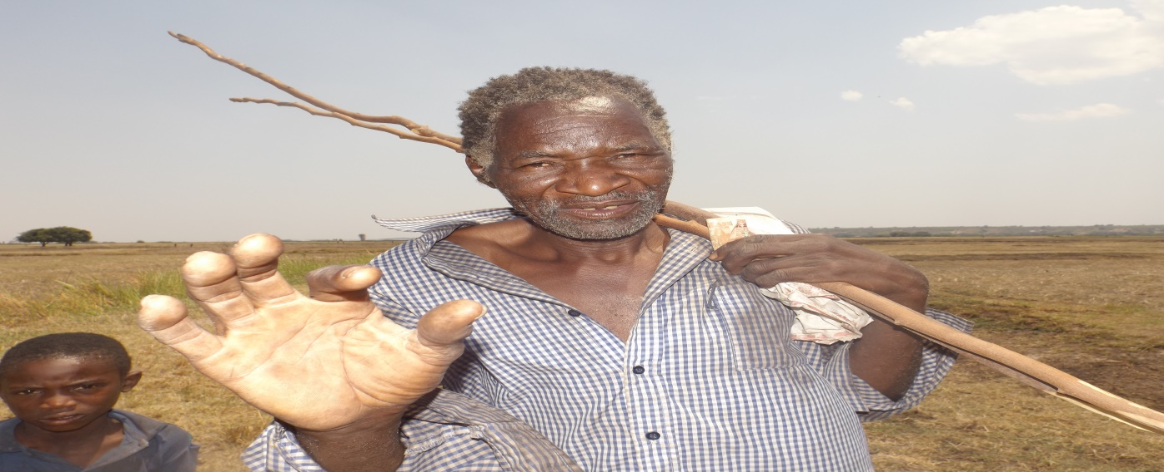
Mr Kelvin Muhongo lost his job as a security guard in a private firm in Mongu town seven months ago after the COVID 19restrictions were imposed and the firm he worked for reduced its work force for lack of business.

Mr Muhongo lost his job seven months ago and was paid 1800 Zambian Kwacha (180 USD) as terminal benefits. He has since returned to his home village of Nakasheke in Sefula. Due to his advancing age, he fills he has no strength left for a formal job but would rather concentrate on his land and look for other coping mechanisms within the community. Today he spends most of his time looking for piecework in rice fields in the Sefula settlement scheme and has also joined village groups strategizing on alternative coping mechanisms. “How are we expected to feed and clothe our families in this kind of a situation? The Government should also look after those of us who are of little means in rural areas otherwise this pandemic, if it comes here, will wipe out all of us.”

COVID 19 impacts on Sefula community happened with speed disrupting the normalcy of the usually well-knit social fabrics and networks in the Sefula community and through which the community depend for its resilience. However, rural folks like Mr Muhongo, have since moved on into the “new normal” environment but the pandemic is still here with us and no one knows for how long. In the absence of Government laid out COVID 19 recovery plan, small scale farmers and local communities have reorganized themselves into groups and made small contributions to help them establish income generating activities. The groups have also been assisted other stakeholders like Non-Governmental Organizations (NGOs) and Faith-Based organizations (FBOs) but the gap still remains. For young children in Kazulu village in Sefula community, the COVID 19 message is very clear “MASK-UP OR YOU DIE!” In answering this clarion call, the children have taken a step forward, within their means, as seen from the photo below (taken by ESAFF Zambia project team):

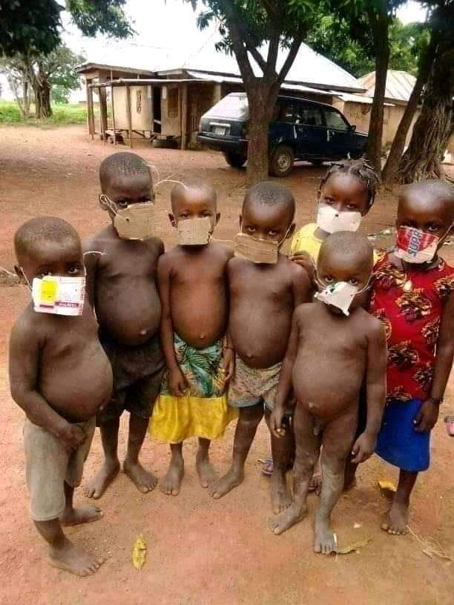
COVID 19- ‘MASK OR YOU DIE!’: For these children from Kazulu village in Sefula community the spirit is willing but the flesh is weak!
SECTION 2 - FINANCIAL REPORT TEMPATE
- Did your organization receive funding from other sources for these response actions to Covid-19? ( ) Yes (✔) No.
If yes, and if possible, please provide us with the names of these other funders (optional)
- In terms of the %, what is the share of this small-grant in the amount of funds you have received to support the response actions for Covid-19?
- Please include any additional information on expenditures that you consider relevant.
- Please copy the budget approved in your contract and fill the last column with the actual expenditure.
Items | Budget approved US$ | Actual Expenditures US$
EXPENSES
Salaries  Program beneficiary targeting/Research  Title of function: Coordination  Sub-total Salaries  Payroll taxes and employee benefits  Description  Description  Sub-total payroll taxes and employee benefits  Sub-grant to other organizations ( include name if known)  Description of services  Description of services  Sub-total Sub-grants  Travel, Conference and meetings  Educational meeting + training  Education for Sefula Community  Sub-total Travel, Conference and meetings  Professional/Consultant services  Media outreach on Covid 19 effect  Training for farmers and educational activities  Description: Trainers/Facilitators  Sub-total professional/Consultant services  Other direct costs  PPE  Water resource production + repair  Agricultural tools + supplies  Fishpond creation/stock  Description:  Sub-total Other Direct Costs  Indirect costs | 400  400  2000  500  2500  1,200  1,500  2,700  400  2,800  4,400  1,800  9,400 | 400  1650  850  950  2,125  840  2,185  4,000  2,000
Total project/Program Budget  (total should tie to total funding above) | 15,000 | 15,000
NET OPERATING  SURPLUS/DEFICIT | - | -

SECTION 3 - ANNEXES
- Please send a copy or link of communication outputs (publications or audiovisual material) produced as part of the actions supported by this grant.
- Please send us photos that could be used to publicize your story in our social media, website and reports. We ask you please to send high resolution photos as separate attached files (or links in Drop Box or via We Transfer https://wetransfer.com). Please include a table in the report annexes section, informing the name of photographer, date (month and year), and description. Use your organization's acronym and number to name the photos (see example below).
File name | Date | Photographer name | Short description
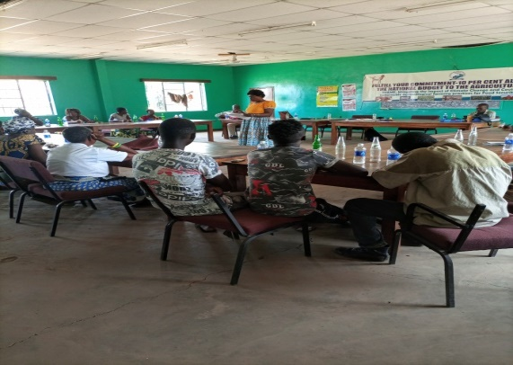ESAFF Zambia_01 | September/2020 | Henry Singili | Agroecology Training session in Sefula Community.
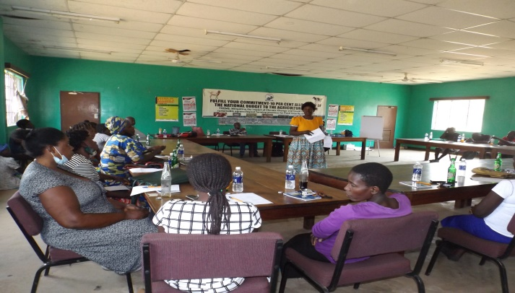ESAFF Zambai_2 | September 2020 | Henry Singili | Training session in Fish farming and livestock husbandry in Sefula Community
ESAFF Zambia_3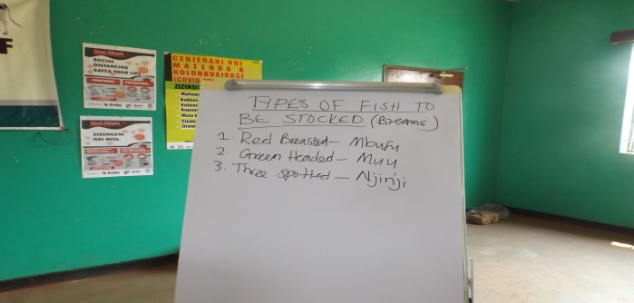 | October 2020 | Henry Singili | Identified fish for restocking in fishponds in Sefula Community
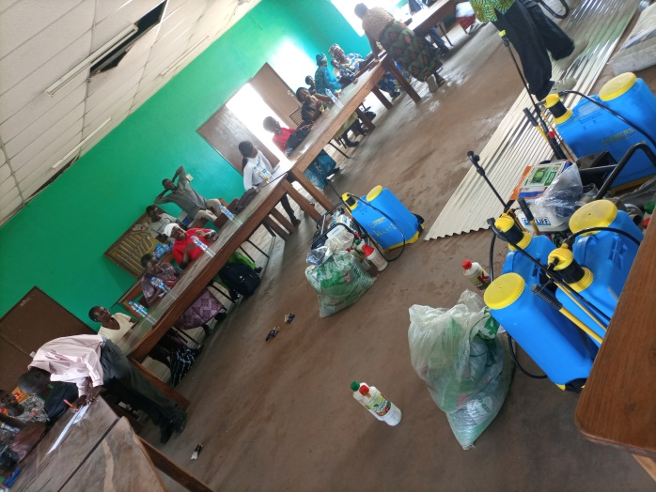ESAFF Zambia_4 | October 2020 | Henry Singili | Distribution of farm inputs for small scale farmers in Sefula community.
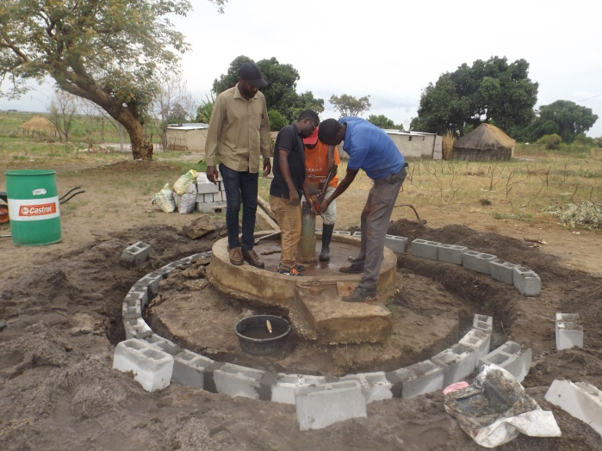ESAFF Zambia_5 | October 2020 | Henry Singili | Rehabilitation of community boreholes in Sefula community
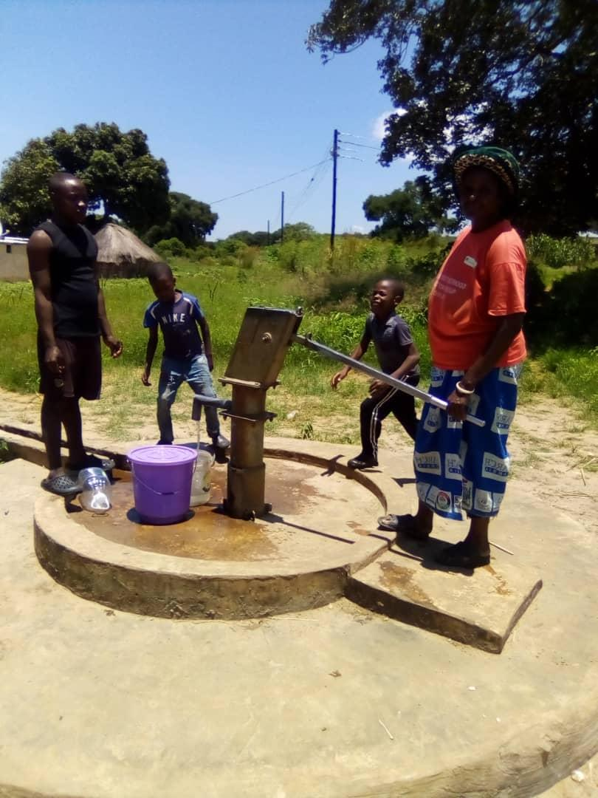ESAFF Zambia_6 | November 2020 | Henry Singili | Rehabilitated bore proving clean water for domestic and livestock
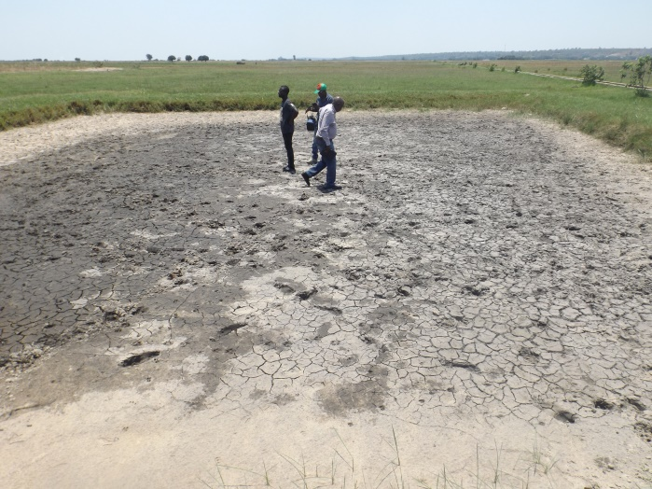ESAFF Zambia_7 | August 2020 | Henry Singili | Identified fishpond for rehabilitation and stocking in Sefula community
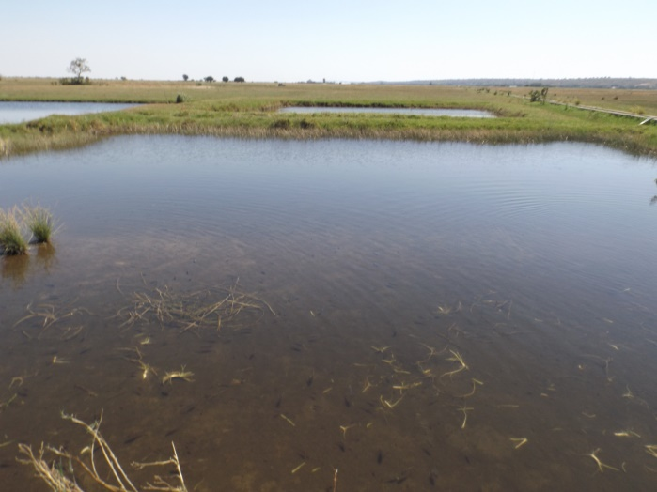ESAFF Zambia_8 | November 2020 | Henry Singili | Fishpond stocked breams in Sefula community
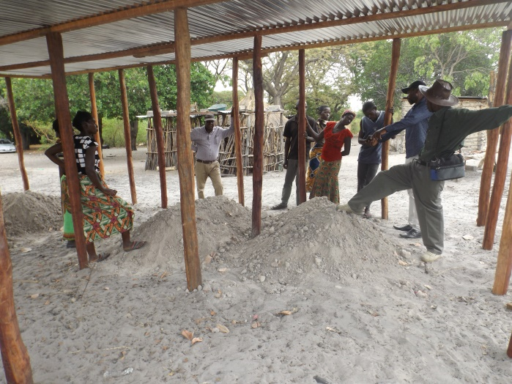ESAFF Zambia_9 | September 2020 | Henry Singili | Construction of a chicken house in Sibata village in Sefula community
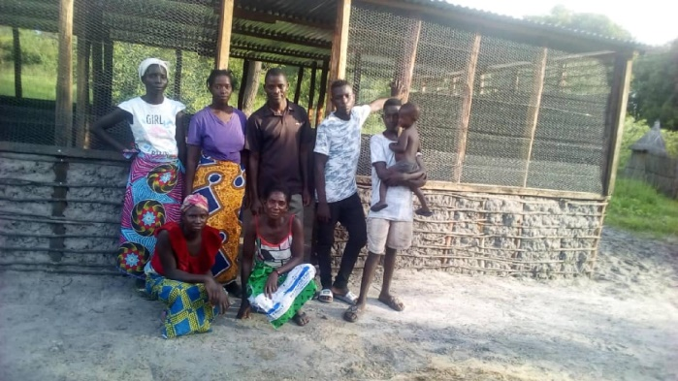ESAFF Zambia_10 | December 2020 | Singili | Completed chicken house in Sibata village in Sefula community to hold 0ver 200 chicken
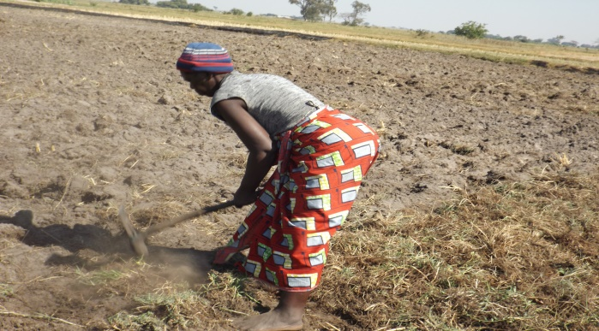ESAFF Zambia_11 | August 2020 | Henry Singili | Woman farmer in Nakasheke village of Sefula community prepares her land to plant winter maize
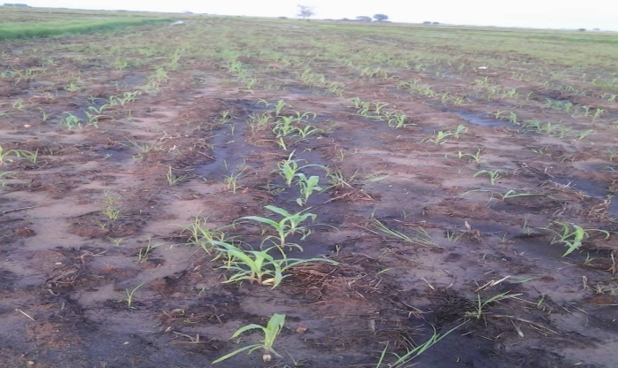ESAFF Zambia_12 | October 2020 | Henry Singili | A woman farmer prepares her farm to plant the winter maize in Nakasheke village of Sefula Community
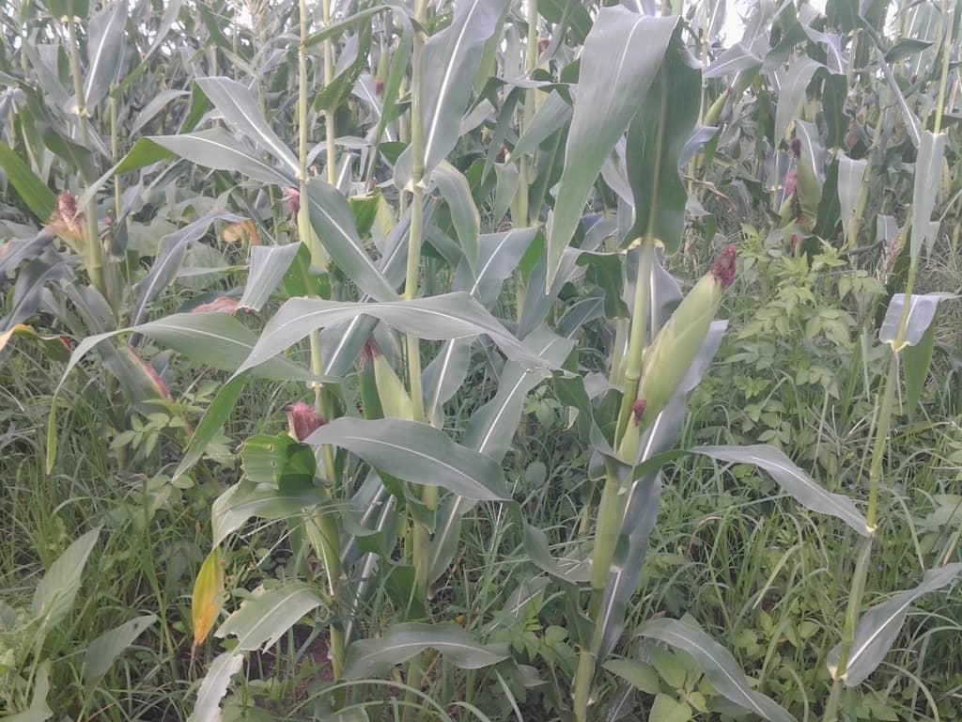ESAFF Zambia_13 | December 2020 | Henry Singili | Winter maize crop in Nakasheke village in Sefula district
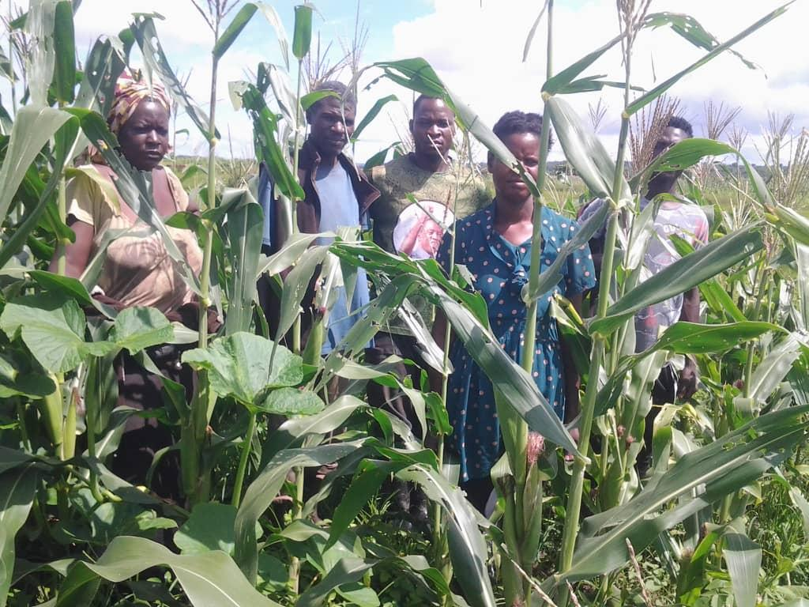ESAFF Zambia_14 | December 2020 | Henry Singili | Young farmers celebrate their winter maize crop
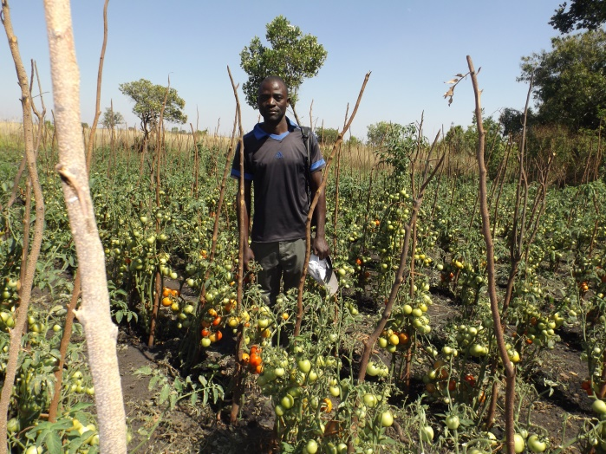ESAFF Zambia_15 | December 2020 | Henry Singili | A young farmer in Nalikolo village Sefula Community.

CERTIFICATION
All East and Southern Africa Small Scale Farmers Forum Zambia activities conducted with the grant funds were and are consistent with charitable purposes are set forthin section 501 (c)(3) forth in the Internal Revenue Code and East and Southern Africa Small Scale Farmers Forum Zambia complied with all provisions and restrictions contained in this Agreement, including, for example and without limitation, those provisions relating to lobbying and political activity.


Signed: HwSingili Date: 28th February 2020

